Αγγλικά – Α Δημοτικού
Όνομα:…………………….……….………
Ημερομηνία: …………..…………………

Handout: Joe’s dream
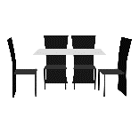= dining room (τραπεζαρία)

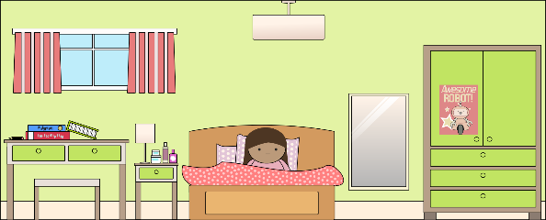
Where is Maria? (που είναι η Μαρία;)
She is in the bedroom (Είναι στο υπνοδωμάτιο)

Is she in the bathroom? (είναι στο μπάνιο;)
No, she isn’t (όχι δεν είναι)
Yes, she is (ναι είναι)
Is she in the bedroom?
1.Yes, he is (ναι είναι)
2. No, he isn’t (όχι δεν είναι)
1. Is Peter happy? (είναι χαρούμενος ο Peter;)
2. Is Peter sad? (είναι λυπημένος ο Peter;)
Αγγλικά – Α Δημοτικού
Όνομα:…………………….……….………
Ημερομηνία: …………..…………………

Worksheet: Joe’s dream
- Match (ταίριαξε)

- We eat in the kitchen
- We sleep in the bathroom
- We cook in the dining room
- We play board games in the garden
- We have a bath in the bedroom
- We ride a bike in the living room

- Choose the correct (διάλεξε το σωστό)

- Where is Maria?
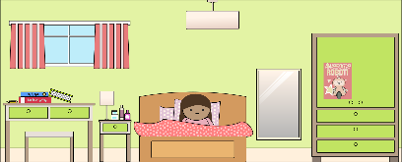
She is in the bedroom she is in the garden she is in the kitchen

- Where is Peter?
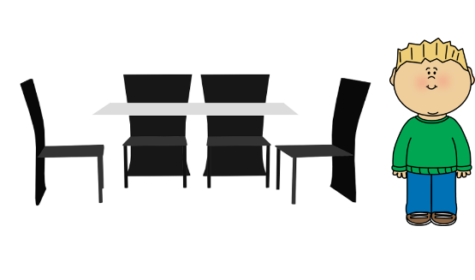
He is in the bedroom He is in the dining room He is in the garden

- Where is Peter?
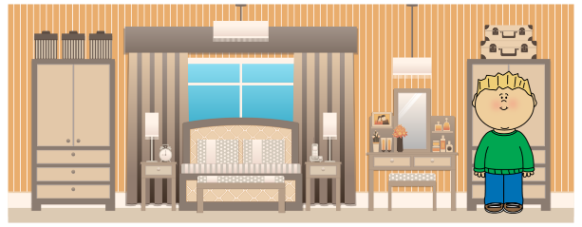
He is in the bathroom she is in the garden He is in the bedroom

- Where is Ann?
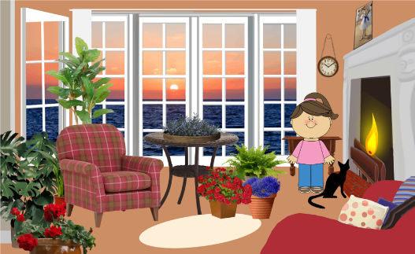
She is in the bedroom she is in the living room she is in the kitchen

- Where is Max?
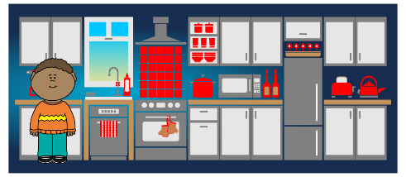
He is in the bathroom He is in the dining room He is in the kitchen

- Where is Ann?
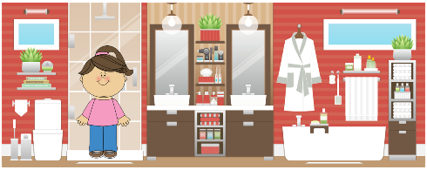
she is in the bedroom she is in the bathroom she is in the garden

