  - English language- 6th grade
Name :…………………….……….………
Date :……….…………..…………………
TEST
(Unit 5/ Lesson 1, 2, 3)

A. Put the sentences in the correct order.
1. food /Do/ not/ or /drink/ consume_______________________________________________________________
2. against /Don't/ door/ lean/ the__________________________________________________________________
3. till /Wait/ the /stops/ train_______________________________________________________________________
4. doors /clear/ Keep/ of/ the ______________________________________________________________________
5. seats /Keep/ feet/ the/ your/ off__________________________________________________________________
6. gap/ between/ platform/ mind/the /train/ and /the
_______________________________________________________________________________________

B. Put the dialogue in the correct order.
1. Is it far?
2. Okay, I will turn left.
3. Excuse me, I think I am lost. Can you help me find my hotel, please?
4. Great. Then go straight on, take the second right and that should take you to the Athens Plaza Hotel.
5. Certainly, What's the name of your hotel?
6. Okay, I will take the second left.
7. No, not really. Actually it's only about 10 minutes walk. Now, go along this street until you get to Syntagma square. At the traffic lights there, turn left to Stadiou Street.
8. Hmm, I think I know where it is.
9. No, it's the second right!
10. It’s the Athens Plaza Hotel.
11. No problem, have a nice day!
12. Got it, thank you very much for your help.
C. Write the odd one out from the group of three.

Odd one | Word | Word | Word
 | ponytail | braids | conductor
 | Omnibus | Admission | tanker
 | simulator | underground | tube
 | Hair brush | Bell-bottomed pants | uniform
 | Way out | exit | lever
 | tunic | beard | toga
 | operate | straight | corner
 | stink | spit | treasure hunt
 | Have a go | Turn left | Go straight
 | perfume | High-heeled shoes | Fruit punch
 | questionnaire | diary | record

D. Form sentences with “used to”.

1. 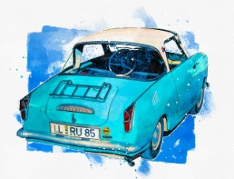 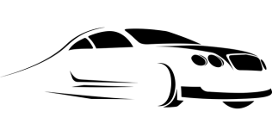
Mario /drive/ vintage car/but/ now /prefer/fast

2. 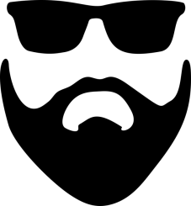
Jack /have/ beard/ but / shave/ now

3. 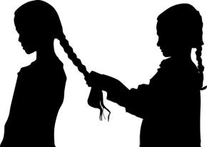
I / have/ longer/ hair /but / now /it /be /short

Key:
Ex.A 1. Do not consume food or drink 2. Don't lean against the door 3.Wait till the train stops 4. Keep clear of the doors 5. Keep your feet off the seats 6. Mind the gap between the train and the platform
Ex.B 3/ 5/ 10/8/1/7/2/4/6/9/12/11
Ex.C conductor, admission, simulator, hair brush, lever, beard, operate, treasure hunt, have a go, fruit punch, record
Ex.D 1. Mario used to drive vintage cars but now he prefers fast cars.
2. Jack used to have a beard but he shaved it now
3. I used to have longer hair but now it is short.

