  - English language- 6th grade
Date:

Lesson Plan
(Unit 5 Lesson 3: The Museum Leaflet)
Class Time: 3 teaching periods
Teaching Aids: Interactive whiteboard, worksheet
Presentation - New Materials | SB, pp. 58-60  Power Point Presentation, Unit 5, Lesson 3  http://photodentro.edu.gr/aggregator/lo/photodentro-lor-8521-6618  http://photodentro.edu.gr/aggregator/lo/photodentro-lor-8521-4792  http://photodentro.edu.gr/aggregator/lo/photodentro-lor-8521-3362
Consolidation - Application | WB, pp. 37, 38, 39, 40, 42
Homework | Worksheet, Unit 5, Lesson 3

Extra activities:
Watch this animated video about the history of transportation.
https://www.youtube.com/watch?v=FaLCQo8NJFA
Watch the video and name different modes of transport. Students guess what is hiding behind the bush and describe the means of transport.
https://en.islcollective.com/video-lessons/land-transportation
You can play this game. The learner's task is to listen to the sounds and choose the correct answer that matches the sound of transportation.
https://en.islcollective.com/video-lessons/transportation-sounds
Watch the video and answer the questions as you go through the rooms of the Sherlock Holmes Museum. Pay attention to the details as well: things in the rooms, people and their actions, etc. Question types: Tap on the picture./Multiple-choice/Complete the sentence.
https://en.islcollective.com/video-lessons/tour-sherlock-holmes-museum
Activities to do in the classroom:
Prepare this worksheet/questionnaire for your class. You can add other types of vehicles if you like. The students can make practice on the description of the vehicles.

Means of transport | Past or Present? | Description (what type of vehicle is it? Is it fast or slow? Is it for young or old people?)
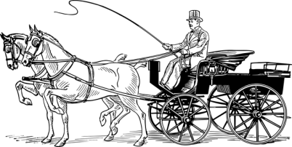
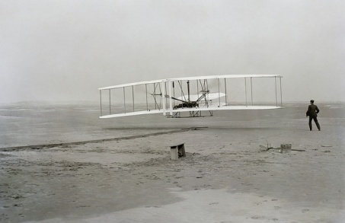
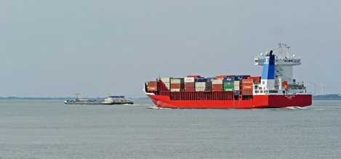

USEFUL VOCABULARY

lesson 3

Charged adj. =με χρέωση

Rate n. = τιμή

Concession n. = προνόμιο

Lift n. = ανελκυστήρας

Ramp n. = ράμπα

Give access v. =παρέχω πρόσβαση

Changing room n. = αποδυτήριο, δοκιμαστήριο

Recorded adj. = ηχογραφημένη

Administration n. = διοίκηση

Education service n. = υπηρεσία εκπαίδευσης

Group booking n. =ομαδική κράτηση

Corporate adj.= εταιρική, επιχειρηματική

Hospitality n. = φιλοξενία

Enquiry n. = ερώτημα, αίτημα

