  - English language- 6th grade
Name :…………………….……….………
Date :……….…………..…………………
WORKSHEET
(Unit 5/ Lesson 2: Trans-portation)

A. Write down the names of the means of transport.

1. 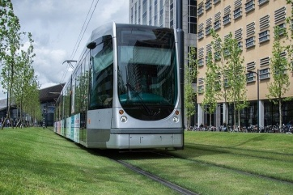 _ _ _ _ 2. _ _ _ _ _ _ _ _ _ _ _

3. _ _ _ _ _ 4. 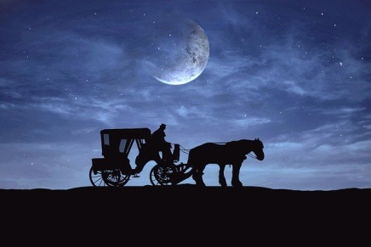 _ _ _ _ _ _ _ _ _ _ _ _ _

5. _ _ _ _ _ _ _ _ _ 6. _ _ _ _ _

B. Match the signs with their meanings.

1. Do not consume food or drink
2. Do not lean against the door. It opens automatically.
3. Mind the gap between the train and the platform
4. Way out
5. Keep clear off the doors
6. Wait till the train stops
7. Be careful of your belongings

a. Προσοχή στο κενό μεταξύ συρμού και αποβάθρας
b. Έξοδος
c. Μην στηρίζεστε στην πόρτα. Ανοίγει αυτόματα.
d. Προσοχή στα προσωπικά σας αντικείμενα
e. Απαγορεύεται η κατανάλωση φαγητού και ποτού
f. Μην εμποδίζετε την έξοδο
g. Περιμένετε μέχρι να σταματήσει ο συρμός

C. Fill in the sentences which are about giving directions.

1. Go ________ ahead and you will see the post office on your right hand.
2. Walk as ________ as the first traffic light that you’ll see and then
3. ________ me, how can I get to the bank?
4. The museum is on the ________ of 5th and 6th avenue.
5. Go ________ the Mercury St. This is where you will take the bus.
6. Could you show me the ________ to the stadium, please?

D. Fill in the table with the phrases accordingly.
{ Cheers/ That's all for now/ Best wishes/ I hope you are well/ Yours/ Take care and write soon/ Lots of kisses/ Thanks for your letter/ It was nice to hear from you/ I'm looking forward to hearing from you/ Love}

Opening paragraphs | Closing paragraphs | Endings

Key:
Ex.A 1. tram 2. underground 3.train 4.horse carriage 5.ambulance 6.truck
Ex.B 1. e 2. c 3.a 4. b 5.f 6.g 7.d
Ex.C 1.straight 2. far 3. Excuse 4. Corner 5. Down 6. way
Ex.D
Opening paragraphs | Closing paragraphs | Endings
I hope you are well | That's all for now | Cheers,
Thanks for your  letter | Take care and write  soon | Love,
It was nice to hear  from you | I'm looking forward  to hearing from you | Lots of kisses,
 |  | Yours,
 |  | Best wishes

Graphics : https://pixabay.com

